**Points of Dispensing (POD) Locator**

Points of Contact:

Eva Islam ([eislam@health.nyc.gov](mailto:eislam@health.nyc.gov))

Mustafa Ali ([mali2@health.nyc.gov](mailto:mali2@health.nyc.gov))

DOITT Ticket Number: KSR000001698132

Expected Completion Date: June, 2019

**Table of Contents**

I. Overview………………………………………………………………………………………………...1

II. Expected Data Flow…………………………………………………………………………………...2

III. Requirements………………………………………………………………………………………….3

IV. Appendix……………………………………………………………………………..………………10

**Version History**

|  |  |  |  |
| --- | --- | --- | --- |
| **Version Number** | **Version Author** | **Changes Made** | **Date Updated** |
| 1 | Eva Islam | Initial Draft | 2/12/2019 |
| 1.2 | Eva Islam | Updated | 3/1/2019 |

**I. Overview**

The Bureau of Emergency Field Operations (BEFO) at the New York City Department of Health and Mental Hygiene (DOHMH) is requesting the creation of a Points of Dispensing (PODs) Locator. The goal of the Locator is to allow members of the public to identify and find their nearest POD Site before and during an emergency. The Locator should allow individuals to search for their address and determine directions to a nearby POD Site. It should also display relevant details such as a POD site’s address as a pop-up on the map, and in list form. Given that this will be a public-facing application, the Locator must be Section 508 Compliant to ensure that it is accessible to individuals with disabilities.

This project is related to the POD Management Tool, an ESRI based product that leverages Survey123 and ArcGIS to enable DOHMH staff members to report operational information from active POD sites. The Locator should mirror the interface and functionality of the NYC Hurricane Evacuation Zone finder[1].

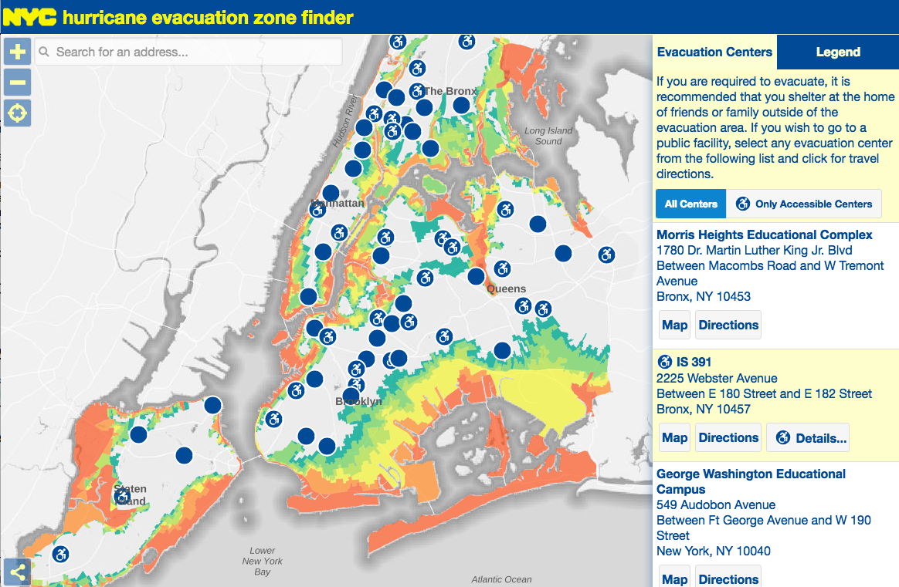

**II. Expected Data Flow**

The Locator should read directly from DOHMH’s ArcGIS Online Locator layer[2]. During a POD activation, staff members at active POD Sites will report out on various indicators including the site’s operations status and its wait time. Individuals will be able to input data directly into their smart phones via Survey123, a form-centric data collection application for ArcGIS Online. Once they have submitted information into the mobile application, the data will populate feature layers in ArcGIS Online. A python script then pushes and pulls these data between ArcGIS Online and a SQL Server database at DOHMH. The Locator layer (*vwLatestDateLocator*) is one of several SQL views that pushes into a feature layer in ArcGIS Online.

ArcGIS Online

DOHMH SQL Server Database

Survey123

(Smart Phone)

DOITT Locator Tool

(maps.nyc.gov)

The POD Locator REST layer is currently public and accessible to anyone on ArcGIS Online. The layer contains the following fields (the bolded fields are collected via Survey123 during an activation):

|  |  |  |  |
| --- | --- | --- | --- |
| **REST URL Field** | **Field Type** | **Length** | **Description** |
| *DOECode* | esriFieldTypeString | 4 | POD site’s 4-character DOE code |
| *PODSiteName* | esriFieldTypeString | 150 | POD site’s name (starting with DOE Code) |
| *Address* | esriFieldTypeString | 50 | POD Site’s Street Address |
| *Borough* | esriFieldTypeString | 15 | POD Site’s Borough |
| *ZIP* | esriFieldTypeString | 5 | POD Site’s Zip Code |
| *Latitude* | esriFieldTypeDouble | -- | POD Site’s Latitude |
| *Longitude* | esriFieldTypeDouble | -- | POD Site’s Longitude |
| ***Ops_status*** | esriFieldTypeString | 16 | POD Site’s Operational Status |
| ***wait_time*** | esriFieldTypeInteger | -- | POD Site’s Wait Time |
| ***LatestDate*** | esriFieldTypeDate | 8 | Date/time data was last updated on Survey123 |
| ***OpeningTime*** | esriFieldTypeDate | 8 | Expected date/time of POD Site’s Opening |

**III. Requirements**

Overview of Requirements:

|  |  |
| --- | --- |
| **#** | **Description** |
| 1 | Locator can rapidly switch between two states following a POD related emergency:  (a) Pre-Activation State  (b) Activation State |
| 2 | Locator can hide data, and change symbology depending on its state |
| 3 | Locator allows users to view POD sites closest to a specified address and obtain directions to a POD site |
| 4 | General notes for Locator aesthetics and text |
| 5 | Locator must be Section 508 compliant and pass review by the NYC DOHMH Communications Office |

*Requirements #1 – Locator can rapidly switch between two states following a POD related emergency: (a) Pre-Activation State (b) Activation State*

Similar to the NYC Hurricane Evacuation Zone finder, the POD Locator must be able to switch between a non-emergency and an emergency state. The Pre-Activation state should display all 165 sites at all times, while the Activation state should hide all inactive POD sites from the map.

1. Pre-Activation State:

In this state, the goal of the Locator is to familiarize members of the public with their closest POD site in the event of an emergency. The Locator should display the *PODSiteName* and *Address* and allow individuals to search for directions from their home/work to a nearby POD site.

1. Activation State:

When PODs are activated, the Locator should hide data for inactive POD sites from the Locator and display active ones as either “Opening Soon, “Open to Public” or “Closed to Public” on the map. The pop-ups and details section should display the appropriate fields from the REST layer depending on the site’s Status. The routing functionality should remain the same as in the Pre-Activation State.

*Requirements #2 – Locator can hide data, and change symbology depending on its state*

1. Pre-Activation State:

**Symbology**:

The sites should have the following symbology when PODs are not active:

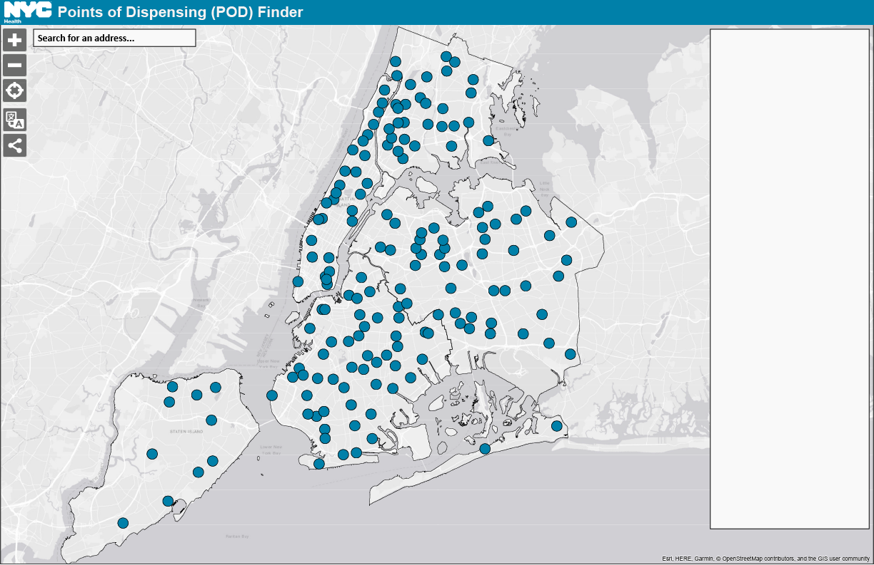

Pre-Activation State:

*Outline color*: #1A1A1A

*Fill color*: #0080A9

*Symbol size*: Same size as symbols in NYCEM Hurricane Evacuation Zone Finder

**Tooltips:**

In the absence of an activation, the tooltips should display the following fields when the user hovers over a POD site in a web browser:

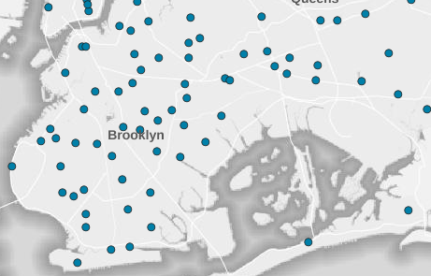

**[POD Site Name]**

[Address]

[Borough], NY [ZIP]

**Pop-Ups and Panel:**

When PODs are not activated, the pop-up for each POD site should only list its address. Similarly, the panel on the right side of the map should only display the site’s address and no other details.

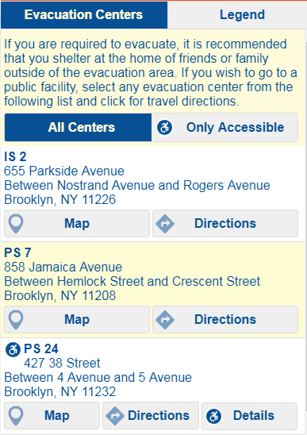

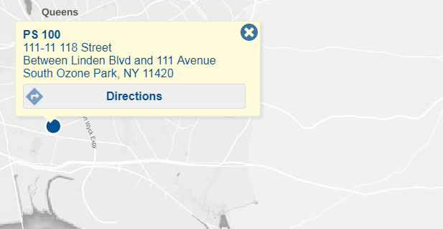

Pre-Activation State:

**[POD Site Name]**

[Address]

[Borough], NY [ZIP]

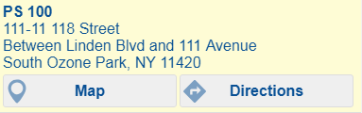

1. Activation State:

**Symbology**:

Following an activation, the Locator should hide any sites that are listed as *Inactive* or without a value (*NULL*) in the REST layer. The POD sites that have statuses listed as either *Open to Public*, *Mobilizing*, *Demobilizing*, *Demobilized*, or *Closed to Public* in the REST layer should be displayed as either “Opening Soon, “Open to Public” or “Closed to Public” on the map. Sites should be grouped by their *Ops_Status* values as denoted below:

|  |  |  |  |  |
| --- | --- | --- | --- | --- |
| Ops_status value | **Hidden** | **“Opening Soon”** | **“Open to Public”** | **“Closed to Public”** |
| Open to Public |  |  | X |  |
| Mobilizing |  | X |  |  |
| Demobilizing |  |  |  | X |
| Demobilized |  |  |  | X |
| Closed to Public |  |  |  | X |
| Inactive | X |  |  |  |
| *NULL* values | X |  |  |  |

The points should be color coded as follows:

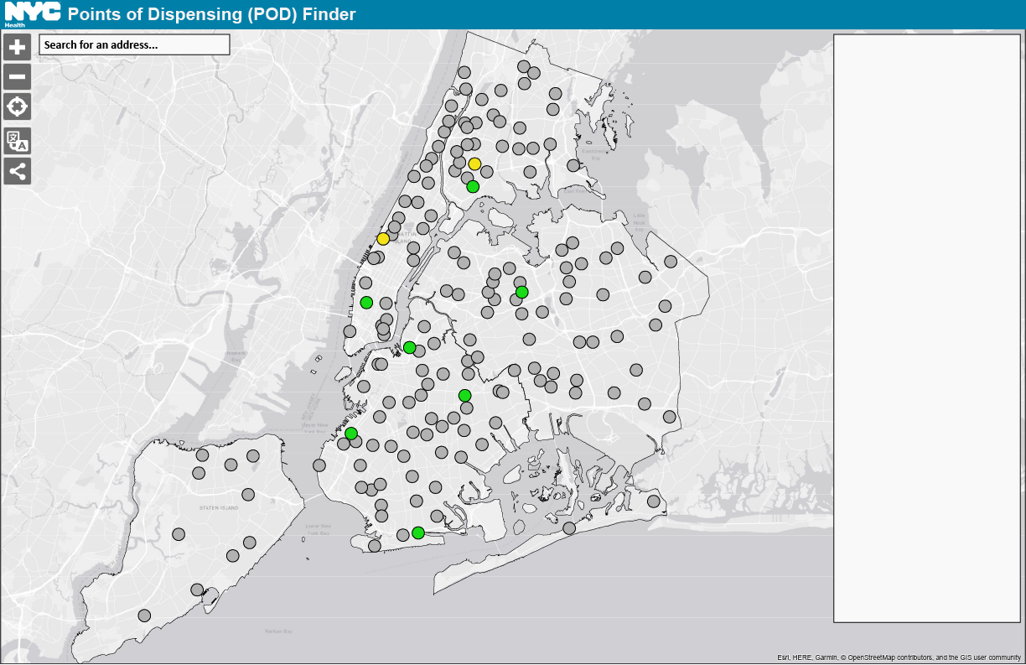

Activation:

**Opening Soon**

*Outline color*: #1A1A1A

*Fill color*: #F3E318

**Open to Public**

*Outline color*: #1A1A1A

*Fill color*: #19DB17

**Closed to Public**

*Outline color*: #1A1A1A

*Fill color*: #999999

*Symbol size for all symbols*: Same size as symbols in NYCEM Hurricane Evacuation Zone Finder

**Tooltips:**

During an activation, the tooltips should display a POD site’s name and address, its status and the fields that would be displayed in the Details section (see following section for more information).



**[POD Site Name]**

[Address]

[Borough], NY [ZIP]

**Status**: [Ops_status]

Fields from Details section

**Pop-ups and Panel**:

Once PODs have been activated following an emergency, the pop-ups and panel should display the following fields in the Details Section for active POD sites. The Details section should not be minimized by default. The fields displayed in the Details section should vary by the POD site’s *Ops-Status.*

|  |  |  |  |
| --- | --- | --- | --- |
| Field Alias (field in REST URL) | **“Opening Soon”** | **“Open to Public”** | **“Closed to Public”** |
| Wait Time (*wait_time*) |  | X |  |
| Opening At (*OpeningTime*) | X |  |  |
| Last Updated (*LatestDate*) | X | X | X |

Activation:

**[POD Site Name]**

[Address]

[Borough], NY [ZIP]

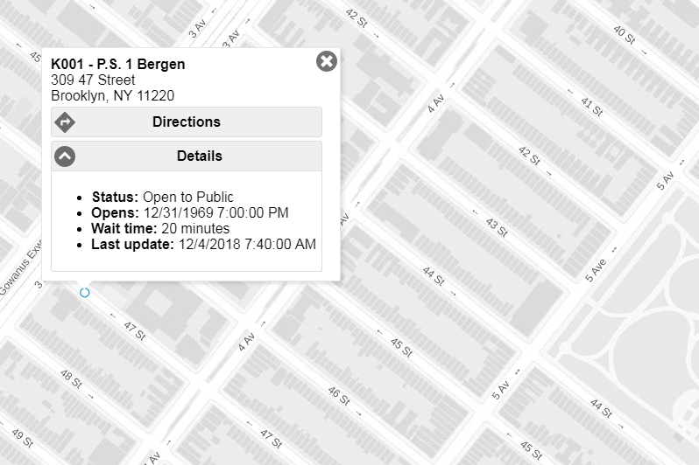

Activation:

If *Ops_status* = **Opening Soon**,

* **Status**: [*Ops_status*]
* **Opening at**: [*OpeningTime*)
* **Last Updated**: [*LatestDate*]

If *Ops_status* = **Open to Public**,

* **Status**: [*Ops_status*]
* **Wait Time**: [*OpeningTime*)
* **Last Updated**: [*LatestDate*]

If *Ops_status* = **Closed to Public**,

* **Status**: [*Ops_status*]
* **Last Updated**: [*LatestDate*]

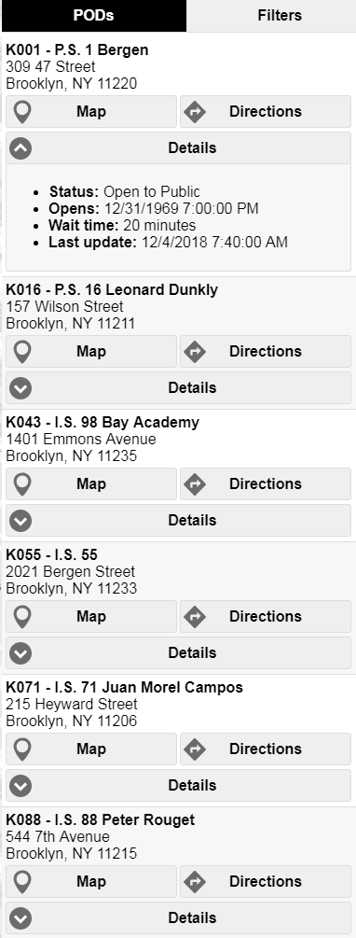

Activation:

Same as pop-up’s information

Activation:

Same as pop-up’s information.

*Requirements #3 - Locator allows users to view POD sites closest to a specified address and obtain directions to a POD site*

Both states of the Locator should allow for the same routing and directions functionality. Users should be able to specify an address in the Search Bar, and the Locator should subsequently zoom to that address on the map. The zoom extent should always include the 3 closest POD sites for the user’s specified address.

Once the Locator displays the closest PODs, the user should be able select one of the sites and determine directions to it from their original address via public transit, driving or walking. In terms of routing, DOHMH would prefer that the Locator automatically default to walking for all requests.

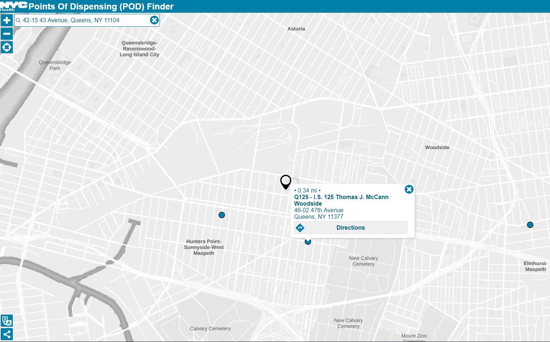

*Requirements #4 - General Requirements for POD Locator*

The following items should always appear on the Locator:

1. The banner at the top of the Locator should say “NYC Points of Dispensing (POD) Finder” at all times. This text should be bolded. The color of the banner should match the teal color from the “Emergency Medication Distribution: Points of Dispensing (PODS)” page on the DOHMH website: #0080A9.[3]
2. The text above the panel should be bolded and say, “All NYC Points of Dispensing sites are wheelchair accessible” at all times.
3. There should be a Home button or something similar that zooms the user back out to show the full extent of the map with all 165 POD sites.

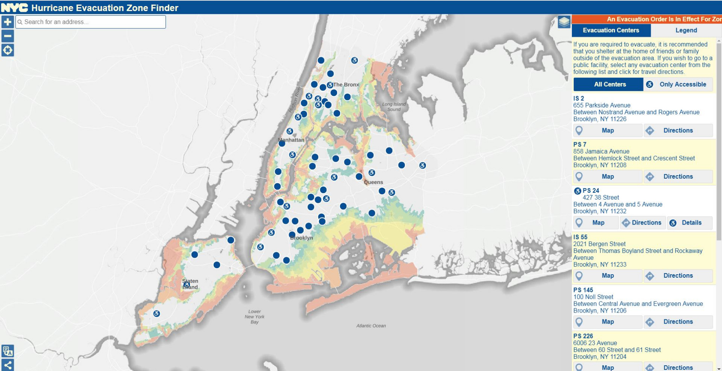

All NYC Points of Dispensing sites are wheelchair accessible.



*From NYC Hurricane Zone Finder4*

*Requirements #4 – Locator must be Section 508 compliant and pass review by the NYC DOHMH Communications Office*

The Locator should incorporate the following items to ensure that it is Section 508 compliant:

1. Colorblind safe symbology
2. High color contrast
3. Accessible fonts
4. Screen reader accessibility
5. Text labels for all links, buttons and form controls
6. Keyboard navigation

**IV. Appendix**

1. NYCEM Hurricane Evacuation Zone Finder (Production):

<https://maps.nyc.gov/hurricane/>

1. DOHMH Locator Layer (*vwLatestDateLocator*) REST URL (No token required): https://services3.arcgis.com/A6Zjpzrub8ESZ3c7/ArcGIS/rest/services/vwLatestDateLocator/FeatureServer
2. DOHMH Points of Dispensing Web Page:

<https://www1.nyc.gov/site/doh/health/emergency-preparedness/emergency-medication-distribution.page>

1. DOHMH Locator Prototype (ArcGIS Online Webapp): <https://nycdohmh.maps.arcgis.com/apps/webappviewer/index.html?id=e4955603fe704405b5f79414e9916600>
2. DOITT POD Finder (Prototype - Development):

<https://csgis-dev-web.csc.nycnet/gis/data/apps/mobile/pods/>

1. DOITT POD Finder (Prototype - Staging):

<https://csgis-stg-prx.csc.nycnet/pods/>

1. DOITT POD Finder Data Uploader:

<https://csgis-stg-prx.csc.nycnet/uploader>

(POD Operations login: [podplanning@health.nyc.gov](mailto:podplanning@health.nyc.gov))

1. NYCEM Hurricane Evacuation Zone Finder (Appendix (1))
2. DOHMH Locator Layer (*vwLatestDateLocator*) REST URL (Appendix (2))
3. 3 DOHMH Points of Dispensing Web Page (Appendix (3))

   4 NYCEM Hurricane Evacuation Zone Finder (Appendix (1))